Ideation Phase
Define the Problem Statements

Date | 01 November 2025
Team ID | NM2025TMID09058
Project Name | Optimizing User, Group, and Role Management with Access Control and Workflows
Maximum Marks | 2 Marks

Customer Problem Statement Template:
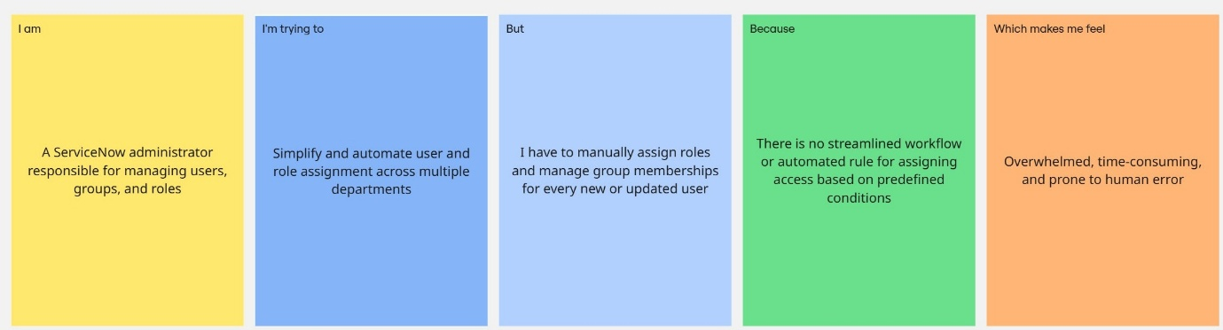

Problem Statement Table:
Problem Statement (PS) | I am (Customer) | I’m trying to | But | Because | Which makes me feel
PS-1 | A ServiceNow administrator who is responsible for managing users, groups, and roles. | To simplify and automate user and role assignments across multiple departments. | I need to manually assign roles and manage group memberships for each new or updated user. | There is no streamlined workflow or automated mechanism for assigning access based on predefined conditions. | It is overwhelming, time-consuming, and highly prone to human error.
PS-2 | An IT manager responsible for ensuring secure, role-based access across the organization. | To implement proper access controls and approval workflows for managing sensitive data and actions. | Access permissions are inconsistently managed, and approval processes are handled manually. | The lack of an automated access control system leads to increased security risks and operational delays. | Concerned about data security vulnerabilities and the lack of operational efficiency.

